Stream change data from Amazon Aurora PostgreSQL to Amazon S3 Tables using Debezium and Amazon MSK Connect
Organizations running transactional workloads on Amazon Aurora PostgreSQL often need to make operational data available for analytics without impacting production performance. This becomes especially challenging when data is distributed across multiple Aurora clusters, making it difficult to join datasets and build cross-domain analytics workflows.
Lakehouse architectures built on Apache Iceberg address these challenges by providing a unified data layer with ACID transactions, schema evolution, and time travel capabilities. Amazon S3 Tables provides native support for Apache Iceberg with automatic snapshot management and compaction, making it an ideal foundation for a governed lakehouse architecture.
However, organizations still need a reliable way to continuously ingest operational database changes into the lakehouse while preserving transactional performance.
In this post, we demonstrate how to build a near real-time change data capture (CDC) pipeline that streams data from Amazon Aurora PostgreSQL into Apache Iceberg tables in Amazon S3 Tables using Debezium, Amazon MSK Connect, AWS Lambda, and Amazon Data Firehose. This architecture enables scalable analytics and lakehouse adoption while keeping transactional workloads isolated from analytics processing.

Solution overview
The following architecture demonstrates how operational changes in Aurora PostgreSQL are captured using logical replication and streamed into Amazon S3 Tables in near real time.
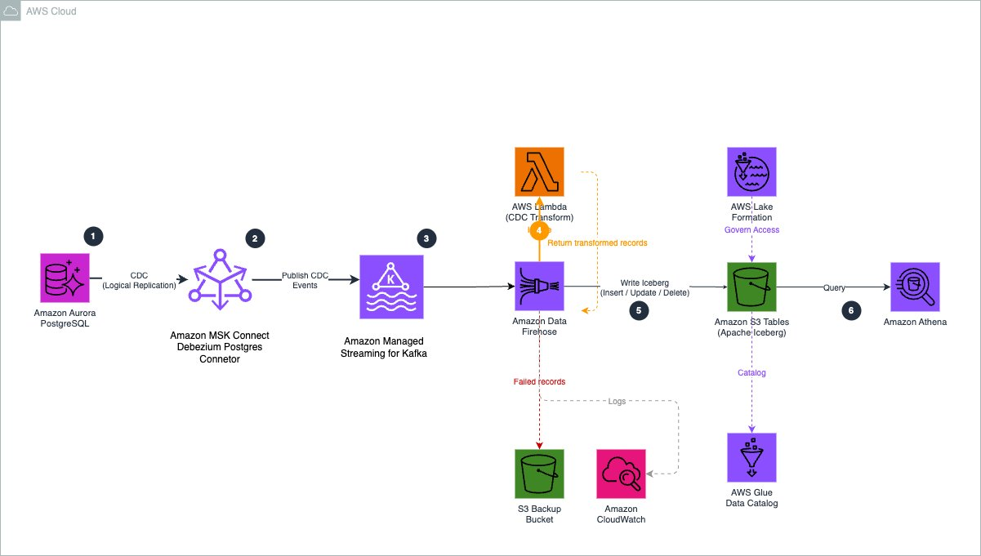

The data flow works as follows:
- Amazon Aurora PostgreSQL captures row-level database changes (insert, update, and delete) using PostgreSQL logical replication.
- Debezium running on Amazon MSK Connect reads the PostgreSQL replication stream and publishes CDC events to Amazon MSK topics.
- Amazon Data Firehose consumes records from the MSK topics and invokes an AWS Lambda function to transform Debezium CDC events into Iceberg-compatible records.
- The Lambda function enriches records with routing metadata that indicates the destination table and the operation type (insert, update, or delete).
- Amazon Data Firehose writes the transformed records to Apache Iceberg tables in Amazon S3 Tables.
- AWS Lake Formation provides centralized governance and access control for the Iceberg tables.
- Downstream analytics tools such as Amazon Athena, Amazon Redshift, or Amazon SageMaker Unified Studio can query the data.

Prerequisites
To follow along, you need the following setup:
- An AWS account with access to the following AWS services:
  - AWS Glue
  - AWS Identity and Access Management (IAM)
  - Amazon S3
  - Amazon Data Firehose
  - Amazon Athena
- Make sure the latest version of AWS Command Line Interface (AWS CLI) is installed and configured.
- Familiarity with the AWS Management Console.
- The AWS CDK installed (we provide CDK stacks for the infrastructure)

Walkthrough
The following steps walk you through this solution.
- Create an S3 table bucket and integrate with AWS Analytics services
Navigate to Amazon S3 in the Console. Choose Table buckets and then Enable integration if the integration with AWS Analytics services isn’t already enabled, as shown in the following figure. This integration allows users to discover all the tables created in this AWS Region and this account in AWS Glue Data Catalog and AWS Lake Formation, and access them through AWS services, such as Firehose, Athena, Amazon Redshift, and Amazon EMR. When the integration is complete, all existing and future table buckets are automatically added as a sub-catalog, namespaces are organized as databases, and the tables within those namespaces are populated as tables in the AWS Glue Data Catalog. To learn more about this integration, refer to Using Amazon S3 with Analytics services.

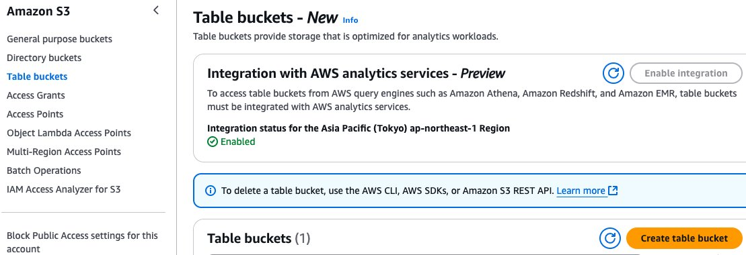

Enable CDC in Aurora PostgreSQL

To enable logical replication in Amazon Aurora PostgreSQL, configure a custom DB cluster parameter group:

- Create a custom parameter group and set the following parameter:
rds.logical_replication = 1
- Apply the parameter group to your Aurora cluster and reboot the cluster for the change to take effect. For more information, see [Logical replication for Aurora PostgreSQL](https://docs.aws.amazon.com/AmazonRDS/latest/AuroraUserGuide/AuroraPostgreSQL.Replication.Logical.html).
- Connect to your Aurora PostgreSQL cluster using your preferred SQL client and create the source tables:
```sql
CREATE TABLE public.orders (
order_id SERIAL PRIMARY KEY,
customer_id INTEGER,
order_date VARCHAR(50),
total_amount DECIMAL(12,2),
status VARCHAR(50),
created_at TIMESTAMP DEFAULT NOW(),
updated_at TIMESTAMP DEFAULT NOW()
);
CREATE TABLE public.products (
product_id SERIAL PRIMARY KEY,
product_name VARCHAR(255),
category VARCHAR(100),
price DECIMAL(10,2),
stock_quantity INTEGER,
created_at TIMESTAMP DEFAULT NOW(),
updated_at TIMESTAMP DEFAULT NOW()
);
- Create a logical replication slot and a publication. The replication slot ensures that PostgreSQL retains WAL segments until Debezium has consumed them, preventing data loss. The publication defines which tables are included in the change stream.
```sql
SELECT pg_create_logical_replication_slot('debezium_slot', 'pgoutput');
CREATE PUBLICATION dbz_publication FOR TABLE public.orders, public.products;
```
- The `pgoutput` plugin is PostgreSQL's native logical decoding output plugin, which is available on Aurora PostgreSQL without any additional extensions.
- Verify that both the replication slot and publication were created successfully:
```sql
SELECT * FROM pg_replication_slots WHERE slot_name = 'debezium_slot';
SELECT * FROM pg_publication WHERE pubname = 'dbz_publication';
```
You should see one row returned for each query, confirming the slot and publication are active.

Important: The replication slot retains WAL segments until consumed. If the Debezium connector is stopped for an extended period, WAL segments accumulate and can cause storage issues on the Aurora cluster. Monitor the `ReplicationSlotDiskUsage` CloudWatch metric for your Aurora cluster.

Build and register the Debezium plugin
MSK Connect runs connectors using custom plugins that you upload to Amazon S3. In this step, you download the Debezium PostgreSQL connector, package it as a ZIP file, upload it to S3, and register it with MSK Connect.
First, download and package the Debezium connector:

```bash
# Download Debezium PostgreSQL connector
DEBEZIUM_VERSION=2.7.3.Final
curl -LO "https://repo1.maven.org/maven2/io/debezium/debezium-connector-postgres/${DEBEZIUM_VERSION}/debezium-connector-postgres-${DEBEZIUM_VERSION}-plugin.tar.gz"
# Extract and package as ZIP for MSK Connect
mkdir -p debezium-plugin
tar -xzf debezium-connector-postgres-${DEBEZIUM_VERSION}-plugin.tar.gz -C debezium-plugin/
cd debezium-plugin && zip -r ../debezium-postgres-connector.zip . && cd ..
```
Upload the ZIP file to an S3 bucket. This bucket must be in the same Region as your MSK cluster:

```bash
aws s3 cp debezium-postgres-connector.zip s3://<your-plugin-bucket>/plugins/
```
Register the uploaded ZIP as an MSK Connect custom plugin:
```bash
aws kafkaconnect create-custom-plugin \
--custom-plugin-name debezium-postgres-connector \
--content-type ZIP \
--location "s3Location={bucketArn=arn:aws:s3:::<your-plugin-bucket>,fileKey=plugins/debezium-postgres-connector.zip}"
```
The command returns a customPluginArn. Note this value you need it for the CDK configuration.
Next, create a worker configuration. The worker configuration tells MSK Connect how to serialize Kafka messages. We configure JSON output without schemas, which produces clean JSON records that the Lambda transform function can parse:
```bash
aws kafkaconnect create-worker-configuration \
--name debezium-worker-config \
--properties-file-content "$(echo -n 'key.converter=org.apache.kafka.connect.json.JsonConverter
value.converter=org.apache.kafka.connect.json.JsonConverter
key.converter.schemas.enable=false
value.converter.schemas.enable=false' | base64)"
```
The command returns a workerConfigurationArn. Note this value as well.
Note: The custom plugin and worker configuration are created via the CLI because the Debezium connector JARs must be downloaded from the Debezium project and packaged manually. The remaining infrastructure is deployed using CDK in the following steps.

Configure CDK
- Clone the sample repository and install dependencies:
```bash
git clone https://github.com/aws-samples/amazon-aurora-cdc-to-s3-tables.git
cd amazon-aurora-cdc-to-s3-tables/cdk
npm install
- ```
- Open `cdk/lib/v2/config.ts` and update the configuration values to match your environment. The configuration file is organized into sections for networking, Aurora, MSK, Debezium, S3 Tables, and Firehose:
```typescript
export const CONFIG = {
account: '<your-account-id>',
region: '<your-region>',
// VPC — must match your Aurora cluster's VPC
vpcId: '<your-vpc-id>',
subnetIds: ['<subnet-1>', '<subnet-2>'],
auroraSecurityGroupId: '<aurora-security-group-id>',
// Aurora connection details
auroraEndpoint: '<aurora-cluster-endpoint>',
auroraPort: '5432',
auroraDbName: '<database-name>',
auroraUser: '<db-user>',
auroraSecretArn: '<secrets-manager-arn>',
// Debezium — use the ARNs from Step 2
debeziumPluginArn: '<customPluginArn-from-step-2>',
debeziumWorkerConfigArn: '<workerConfigurationArn-from-step-2>',
debeziumPluginBucket: '<your-plugin-bucket-name>',
debeziumTopicPrefix: 'aurora.cdc',
debeziumTables: 'public.orders,public.products',
// S3 Tables — the table bucket name must be globally unique
s3TablesBucketName: '<your-table-bucket-name>',
s3TablesNamespace: 'aurora_cdc',
tables: ['orders', 'products'],
tableKeys: { orders: 'order_id', products: 'product_id' },
// Firehose — general purpose S3 bucket for failed record backup
firehoseBackupBucket: '<your-backup-bucket-name>',
...
};
Key configuration notes:
- - **`auroraSecurityGroupId`** — The security group attached to your Aurora cluster. The CDK creates an MSK security group with ingress rules allowing traffic from this Aurora security group, and a reverse rule allowing MSK Connect workers to reach Aurora on port 5432 for CDC reads.
- - **`debeziumTopicPrefix`** — Determines the Kafka topic naming pattern. Debezium creates topics as `<prefix>.public.<table-name>`, but the `ByLogicalTableRouter` SMT reroutes all events to aurora.cdc.all-tables.
- - **`tableKeys`** — The primary key column for each table. Firehose uses these to match incoming records against existing rows for update and delete operations in the Iceberg tables.
- - **`s3TablesBucketName`** — The name for your S3 table bucket. Table bucket names must be globally unique across all AWS accounts, similar to general purpose S3 bucket names.
- ### Step 4: Deploy the CDK stacks
Deploy all eight stacks with a single command. CDK resolves the dependency order automatically:
```bash
npx cdk —app "npx ts-node bin/app-v2.ts" deploy —all
```
When prompted, review the IAM changes and confirm the deployment. The CDK deploys the following stacks in dependency order:
 | Stack | What it creates
1 | CdcMskCluster | MSK cluster (2× kafka.m5.large brokers) with dual authentication (IAM for Firehose, unauthenticated for Debezium), multi-VPC private connectivity for Firehose PrivateLink, custom configuration with auto.create.topics.enable=true, MSK security group with ingress rules for Aurora and self-referencing rules for MSK Connect workers
2 | CdcMskConnectIam | MSK Connect service execution role with permissions for Kafka cluster operations, VPC networking, S3 plugin access, and Secrets Manager; plugin S3 bucket with SSE encryption and SSL-only policy; CloudWatch log group for connector logs
3 | CdcDebeziumConnector | Debezium PostgreSQL connector with ByLogicalTableRouter Single Message Transform (SMT) that routes CDC events from all three tables to a single Kafka topic (aurora.cdc.all-tables); provisioned capacity with 2 MCU × 2 workers
4 | CdcS3Tables | S3 table bucket, aurora_cdc namespace, and two Iceberg tables (orders, products) with full column schemas matching the Aurora source tables
5 | CdcLambdaTransform | Lambda function (firehose-debezium-transform) that converts Debezium CDC envelope format to flattened JSON, maps operation types, and sets otfMetadata routing for multi-table delivery
6 | CdcFirehoseRole | Firehose IAM role with permissions for MSK (including kafka:CreateVpcConnection for PrivateLink), S3 Tables, Glue Data Catalog, Lake Formation, VPC networking, Lambda invocation, and CloudWatch logging
7 | CdcLakeFormation | Lake Formation database-level and table-level permissions (ALL) for the Firehose role on the S3 Tables sub-catalog; MSK cluster resource policy allowing the Firehose service principal to create VPC connections
8 | CdcFirehose | Firehose delivery stream with MSK as source (private connectivity via PrivateLink), Lambda processing for CDC transformation and routing, Apache Iceberg Tables as destination with three table configurations, 1 MiB / 60-second buffer hints, and S3 backup bucket for failed records
**Note:** The MSK cluster takes approximately 25 minutes to create. The Debezium connector takes approximately 5 minutes after the cluster is ready. You can monitor the deployment progress in the AWS CloudFormation console. The total deployment time is approximately 35–40 minutes.
**Note:** The Lake Formation permissions use the S3 Tables sub-catalog format (`<account-id>:s3tablescatalog/<table-bucket-name>`) for the `CatalogId` parameter. This format is not supported by the native `AWS::LakeFormation::PrincipalPermissions` CloudFormation resource, so the CDK stack uses an `AwsCustomResource` construct to grant permissions via the AWS SDK.

Verify the Debezium connector

After the CDK deployment completes, verify that the Debezium connector is running and has completed its initial snapshot of the source tables.
Check the connector status:
```bash
aws kafkaconnect list-connectors —region <your-region> \
—query 'connectors[?connectorName==`aurora-postgres-debezium-connector`].{Name:connectorName,State:connectorState}' \
—output table
```
You should see output similar to:
-------------------------------------------------------------
| ListConnectors |
+------------------------------------------+----------------+
| Name | State |
+------------------------------------------+----------------+
| aurora-postgres-debezium-connector | RUNNING |
+------------------------------------------+----------------+
Next, check the CloudWatch logs to confirm the connector has completed its initial snapshot and started streaming:
```bash
aws logs tail /aws/msk-connect/aurora-cdc-debezium —follow —region <your-region>
```
You should see messages indicating the snapshot phase completing and the transition to streaming mode:
```
Finished exporting 0 records for table 'public.orders' (1 of 2 tables)
Finished exporting 0 records for table 'public.products' (2 of 2 tables)
Snapshot completed
Starting streaming
```
If the tables were empty when the connector started, the export count is 0. If you had existing data, the snapshot captures all existing rows as `r` (read) operations, which the Lambda function maps to `insert` operations in the Iceberg tables.
You can also verify that the Firehose delivery stream is active:
```bash
aws firehose describe-delivery-stream \
—delivery-stream-name msk-to-s3tables-firehose \
—region <your-region> \
—query 'DeliveryStreamDescription.DeliveryStreamStatus'
```
The status should return ACTIVE.

Test the pipeline with sample data
With the pipeline running, insert test data into the Aurora PostgreSQL source tables. Each insert triggers a CDC event that flows through the pipeline: Aurora WAL → Debezium → MSK topic → Firehose → Lambda transform → S3 Tables.

Connect to your Aurora PostgreSQL cluster and run the following inserts:
```sql
-- Insert orders
INSERT INTO public.orders (customer_id, order_date, total_amount, status)
VALUES
(1, '2026-01-20', 299.99, 'shipped'),
(2, '2026-01-21', 149.50, 'processing'),
(1, '2026-01-22', 89.99, 'delivered');
-- Insert products
INSERT INTO public.products (product_name, category, price, stock_quantity)
VALUES
('Wireless Headphones', 'Electronics', 79.99, 150),
('Running Shoes', 'Sports', 129.99, 75),
('Coffee Maker', 'Kitchen', 49.99, 200);
```
This creates 6 records across 2 tables. Each record generates a Debezium CDC event with operation type `c` (create), which the Lambda function maps to an `insert` operation in the corresponding Iceberg table.

- ### Step 8: Query data using Amazon Athena
- With data delivered to S3 Tables, you can query the Iceberg tables using Amazon Athena. S3 Tables integrates with the AWS Glue Data Catalog as a sub-catalog, so you reference tables using the S3 Tables catalog format.
- Open the Athena console, select the **AwsDataCatalog** data source, and run the following queries:
- ```sql
- -- Query orders table
- SELECT * FROM "s3tablescatalog/<table-bucket-name>"."aurora_cdc"."orders";
- -- Query products table
- SELECT * FROM "s3tablescatalog/<table-bucket-name>"."aurora_cdc"."products";
- ```
- Replace `<table-bucket-name>` with your S3 table bucket name. You should see the 3 records in each table that you inserted in Step 6.
- Now test that update and delete operations propagate correctly through the pipeline. Run the following statements in Aurora:
- ```sql
- -- Update an order status
- UPDATE public.orders SET status = 'delivered' WHERE order_id = 2;
- -- Delete a product
- DELETE FROM public.products WHERE product_id = 3;
- ```
- Wait 60–90 seconds for the changes to propagate, then query Athena again:
- ```sql
- -- Verify the update: order_id 2 should now show 'delivered'
- SELECT order_id, status FROM "s3tablescatalog/<table-bucket-name>"."aurora_cdc"."orders";
- -- Verify the delete: product_id 3 (Coffee Maker) should be removed
- SELECT product_id, product_name FROM "s3tablescatalog/<table-bucket-name>"."aurora_cdc"."products";
- ```
- The orders table should show `delivered` for order 2, and the products table should contain only 2 records (Wireless Headphones and Running Shoes). This confirms that the pipeline correctly handles all three CDC operation types: inserts, updates, and deletes.
- > **Note:** Because S3 Tables provides automatic compaction and snapshot management for Iceberg tables, you do not need to run manual maintenance operations. S3 Tables handles compaction of small files and expiration of old snapshots automatically.
- You can also use Iceberg's time travel capability to query the table as it existed before the updates:
- ```sql
- -- Query the orders table as of 5 minutes ago
- SELECT * FROM "s3tablescatalog/<table-bucket-name>"."aurora_cdc"."orders"
- FOR TIMESTAMP AS OF current_timestamp - interval '5' minute;
- ```
- This returns the original data before the update, demonstrating the time travel capability that Iceberg provides through S3 Tables.

CDC changes reflected in the Iceberg tables
The screenshots below show the result of performing several operations in the Aurora source database, including updates, inserts, and deletes.

In the products table:
- The rows highlighted in yellow represent records that were updated in the source database.
- The rows highlighted in green represent new records that were inserted.
- The record labeled in red indicates a row that was deleted in Aurora and therefore no longer appears in the destination table.
Similarly, in the orders table, updates and newly inserted records are reflected in the Iceberg table shortly after the changes occur in Aurora.
These examples demonstrate how the CDC pipeline continuously propagates operational database changes into the lakehouse, keeping the Amazon S3 Tables Iceberg tables synchronized with the source Aurora database.

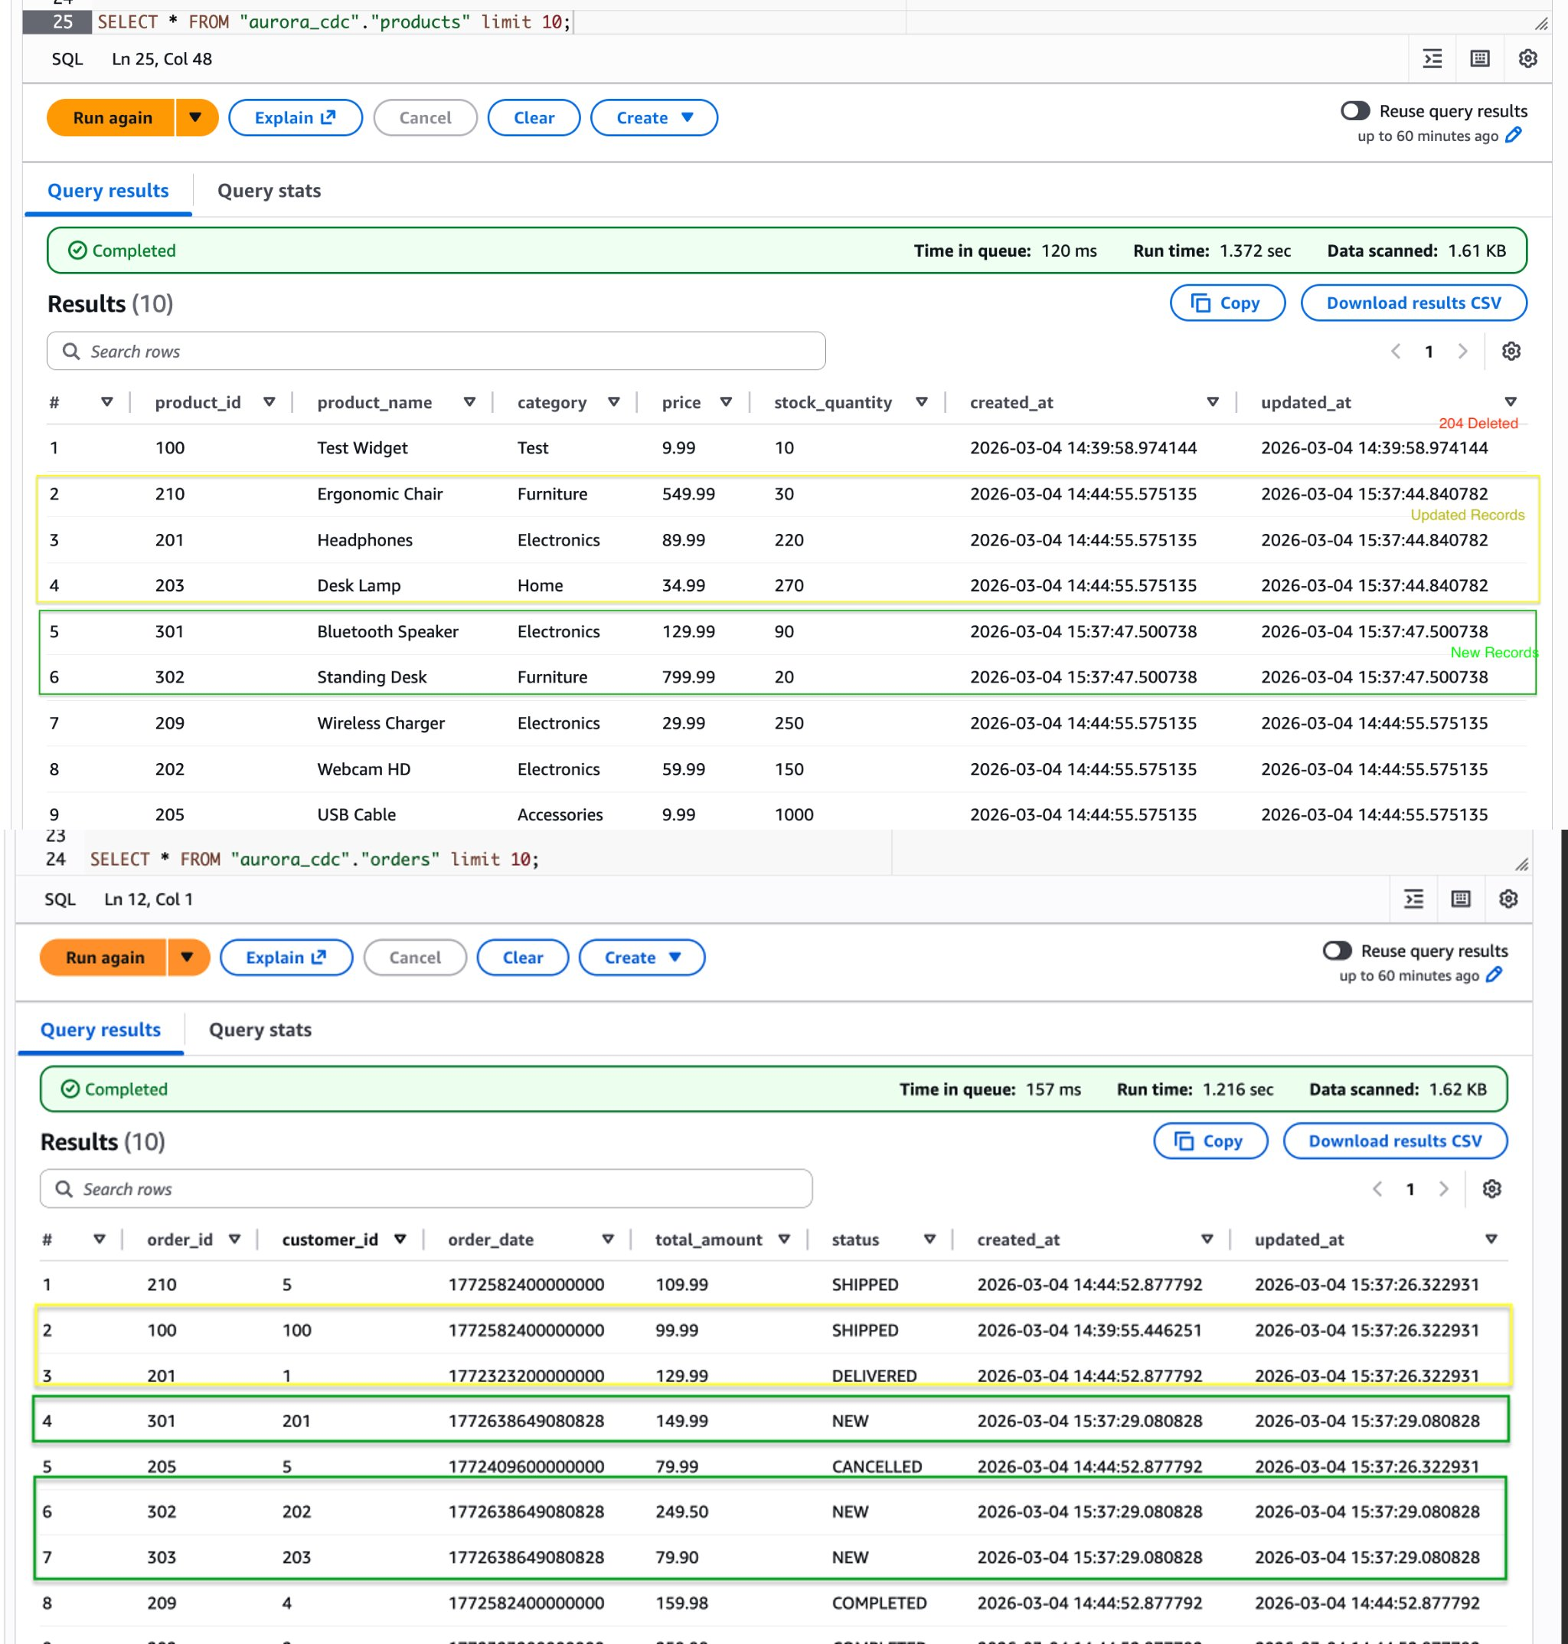

Cleaning up

To avoid ongoing charges, delete the resources in reverse dependency order. The MSK cluster is the largest cost driver and cannot be paused only deleted.
Delete the CDK stacks:
```bash
cd cdk
npx cdk —app "npx ts-node bin/app-v2.ts" destroy —all
```
When prompted, confirm the deletion of each stack. The stacks are deleted in reverse dependency order automatically.

Delete the Debezium custom plugin and worker configuration that were created via CLI in Step 2:
```bash
aws kafkaconnect delete-custom-plugin —custom-plugin-arn <plugin-arn>
aws kafkaconnect delete-worker-configuration —worker-configuration-arn <worker-config-arn>
```
Finally, clean up the Aurora PostgreSQL replication resources to stop WAL retention:
```sql
-- Connect to Aurora PostgreSQL
SELECT pg_drop_replication_slot('debezium_slot');
DROP PUBLICATION dbz_publication;
Important: If you plan to redeploy the pipeline later, you do not need to drop the replication slot and publication. However, be aware that the replication slot continues to retain WAL segments while the connector is not running, which can increase storage usage on the Aurora cluster.

Operational best practices

Consider the following best practices when running this pipeline in production:
- Monitor connector health – Set up CloudWatch alarms on MSK Connect connector status and Firehose delivery metrics. Key metrics include `IncomingRecords`, `DeliveryToIceberg.Success`, and `DeliveryToIceberg.Failure`.
- Handle schema evolution – When you add columns to Aurora tables, Debezium automatically captures the schema change. Update the corresponding Iceberg table schema to include the new columns before the changed records arrive. S3 Tables supports schema evolution through the `ALTER TABLE` statement in Athena.
- Tune buffer settings – Adjust Firehose buffer size and interval based on your latency and cost requirements. Smaller buffers reduce latency but increase the number of small files. S3 Tables' automatic compaction helps mitigate the small file problem.
- Secure the pipeline – Use IAM authentication for MSK, encrypt data in transit with TLS, and use Lake Formation for fine-grained access control on the Iceberg tables. Store database credentials in AWS Secrets Manager rather than in connector configuration.
- Plan for failure recovery – Firehose automatically retries failed deliveries and sends undeliverable records to the backup S3 bucket. Monitor the error prefix in your backup bucket and set up alerts for failed records. MSK retains messages based on your retention policy, allowing replay if needed.

Clean up

To avoid incurring charges, delete the following resources:
- The Firehose delivery stream
- The MSK Connect connector
- The MSK cluster (if created for this demo)
- The S3 table bucket and tables
- The Lambda function
- The S3 backup bucket
- CloudWatch log groups
- IAM roles created for this solution
If you deployed using the CDK stacks, run `cdk destroy --all` to remove the resources.

Conclusion

In this post, we demonstrated how to build a near real-time CDC pipeline from Amazon Aurora PostgreSQL to Amazon S3 Tables using Debezium, Amazon MSK Connect, AWS Lambda, and Amazon Data Firehose. This architecture enables organizations to continuously stream operational data into a governed Iceberg-based lakehouse without impacting production workloads.

The key benefits of this approach include:
- Fully managed – MSK Connect runs Debezium without infrastructure management, and Firehose handles delivery with automatic retries and error handling
- Near real-time – Changes in Aurora are available in S3 Tables within seconds
- CDC semantics preserved – The Lambda transform maps Debezium operations to Iceberg insert, update, and delete operations, keeping the lakehouse in sync with the source
- Governed access – Lake Formation provides centralized access control over the Iceberg tables
- Cross-domain analytics – Data from multiple isolated Aurora clusters can be unified in a single S3 Tables namespace, enabling joins and analytics that weren't possible before
This pattern is well suited for organizations transitioning to a lakehouse strategy who need to onboard operational data from Aurora into analytics platforms such as Amazon Athena, Amazon Redshift, or Amazon SageMaker Unified Studio. We encourage you to try this solution and adapt it to your use case.

